FRIENDS OF HOLY FAMILY PRIMARY SCHOOL
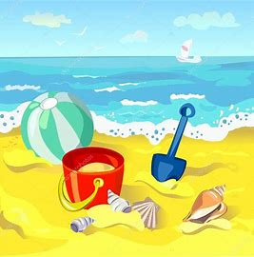
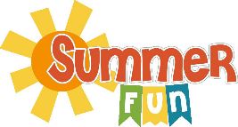

Dear Parents/Guardians,
This year as part of our Summer fundraiser, the Friends of Holy Family Primary School are inviting parents from Primary 5 and Primary 6 to donate items, if they can, for the Summer Fun hampers. If you do not have a child in either class and would like to contribute to the fundraiser, all donations would be greatly appreciated by Friday 4th June.
Suggested items: Gift vouchers, confectionery, chocolates, outdoor games (sprinkler toys, paddling pool, badminton/tennis rackets, hula hoop, water gun, frisbee, football, bubble wand/machine, giant chalk, buckets/spade etc) yoyo, sunglasses, ice pop moulds, board games, card games etc.
Friends of Holy Family will also be contributing items towards the hampers to ensure lots of Summer Fun will be had.
Many thanks for your continued support!

Friends of Holy Family Primary School

FRIENDS OF HOLY FAMILY PRIMARY SCHOOL
Dear Parents/Guardians,
This year as part of our Summer fundraiser, the Friends of Holy Family Primary School are inviting parents from Primary 5 and Primary 6 to donate items, if they can, for the Summer Fun hampers. If you do not have a child in either class and would like to contribute to the fundraiser, all donations would be greatly appreciated by Friday 4th June. Suggested items: Gift vouchers, confectionery, chocolates, outdoor games (sprinkler toys, paddling pool, badminton/tennis rackets, hula hoop, water gun, frisbee, football, bubble wand/machine, giant chalk, buckets/spade etc) yoyo, sunglasses, ice pop moulds, board games, card games etc.
Friends of Holy Family will also be contributing items towards the hampers to ensure lots of Summer Fun will be had.
Many thanks for your continued support!

Friends of Holy Family Primary School

