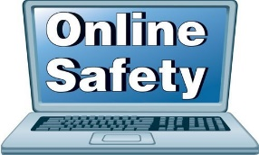
October 2020

YouTube

What is YouTube?
YouTube lets you watch, listen, stream, create and comment on videos. YouTube is intended for users over the age of 13, however the App Store rates YouTube as 17+ due to the content that can be found there.

How can I make YouTube safer?
There are some steps that you can take to make it a safer environment for your child:
- Turn on restricted mode – this mode restricts the availability of mature content. You will need to set up a Google account to do this. Once set up, you can find this setting in options.
- Sit with your child and see what they are watching or set rules that devices should only be used in family areas.
- Ensure your child knows how to report inappropriate content.
- Make sure your child understands that they can talk to you if they see anything that makes them feel uncomfortable online.

YouTube Kids
YouTube recommend that YouTube Kids is used for children under the age of 13 as it provides a safer environment and offers greater controls such as being able to customise your child’s viewing (You can select the shows that you prefer your child to watch).
Use this link to find out how to set up parental controls on YouTube Kids: https://support.google.com/youtubekids/answer/6172308?hl-en-GB

Posting Videos
To post videos on YouTube, you should be over 13 years of age. Talk to your child about posting videos, do they understand what information they should keep private and what to do if they receive any negative comments> YouTube have produced these tips for those that do upload content:
https://support.google.com/youtube/answer/2802244?hl-en-GB

