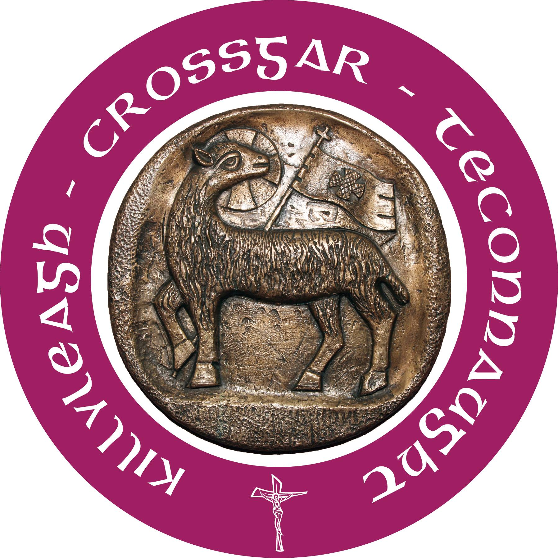

Kilmore & Killyleagh
Parishes

14th May 2017

Fifth Sunday of Easter

Father Donald Kettle Adm
Parochial House
10 Downpatrick Street
Crossgar BT30 9EA
Tel: (028) 4483 0229
Email: d.kettle@downandconnor.org

Father Brendan Smyth PP
Parochial House
4 Irish Street
Killyleagh BT30 9QS
Tel: (028) 4482 8211
Email: b.smyth@downandconnor.org

Parish Office: 02844830229 “Omnia in Bonum”
Opening hours: Tuesday – Thursday 2pm-4.30pm
Email: kilmoreandkillyleagh@downandconnor.org

All bulletin notices can be emailed to the office email address marked “bulletin”. Notices must be in by Wednesday.

Safeguarding: (Tel: 02844830229)
Chair: Mary Jo Bell Vice-Chair: Patricia Murray

Parish Schools:
St Joseph’s Primary
Tel: (028) 44830810
Principal: Mrs Siobhan McArdle
www.stjosephsps.org.uk

Crossgar: St Colmcille’s High
Tel: (028) 44830311
Principal: Mr Shane McNeill
www.stcolmcillescrossgar.org.uk
Teconnaught: Holy Family Primary
Tel: (028) 44830319
Principal: Mr Christopher Curran
www.holyfamilyps.co.uk

Killyleagh: St Mary’s Primary
Tel: (028) 44828542
Principal: Mrs Dolores Miller
www.stmaryspskillyleagh.com
Sunday Mass Times:
Crossgar: Sunday 9.30am & 11am
Killyleagh: Saturday 5.30pm Vigil
Teconnaught: Saturday 6.30pm Vigil

Weekday Mass Times:
Crossgar: Tuesday & Friday 9.30am Wednesday 7.30pm
Killyleagh: Monday 7.30pm
Tues, Wed & Thurs 9.30am
Teconnaught: Monday 9.30am Thursday 7.30pm

Confession Times:
Crossgar: Wednesday 6.30-7.15pm
Killyleagh: Saturday 5.00-5.20pm
Teconnaught: Saturday 5.30-6.15pm
Tobar Mhuire: Thursday before First Friday 4-6pm
Friday & Saturday 4.00-6.00pm

The Apostolate of Eucharistic Adoration:
Perpetual Adoration takes place in the Parish at:
Crossgar: Tuesday 10.00am - 8.00pm
Killyleagh: Wednesday 10.00am -11.00am
Teconnaught: Thursday 6.30pm - 7.30pm
Tobar Mhuire: Wednesday 6.00pm - 9.00pm
Friday 4.00pm - 6.00pm
The Blessed Sacrament cannot be left unattended.

Weddings:
To make a wedding booking please contact the parish office by email or phone. Three months notice required.

Baptism Times:
Baptisms will take place at 12.15pm
- Crossgar: 2nd Sunday of each month
- Teconnaught: 3rd Sunday of each month
- Killyleagh: 4th Sunday of each month

Weekly Collection:
We acknowledge with thanks and appreciation last week’s offerings.

Parish Ministries:
Next week’s volunteers are as follows:
See rotas on notice boards for more details.
Readers: 20th & 21st May
Crossgar:
Sun: 9.30am Paul Flanagan & Monica Devlin
Sun: 11.00am Willie Hanna & Maria Downard
Killyleagh:
Sat: 5.30pm Lauren Rose Fegan & Antonia O’Goan
Teconnaught:
Sat: 6.30pm Denis Cahill & Frances Martin

Extraordinary Ministers of Holy Communion:
20th & 21st May
Crossgar:
Sun: 9.30am Frank Hanna
Sun: 11am Patricia Murray & Margaret Mulhern
Killyleagh:
Sat: 5.30pm Chris Quinn & Patricia Oakes
Teconnaught:
Sat: 6.30pm Paul O’Kane, Claire O’Kane & Harry Mulholland
Children’s Liturgy:
20th & 21st May
Crossgar: Eimhear O’Prey & Marcelle Orsi
Killyleagh: Michelle Knowles & Kathryn Clark
Teconnaught: Deirdre Nelson & Tracy Harkin

Altar Society:
Crossgar: Group 1
Teconnaught: Group 5

Our Lady’s Statue Killyleagh:
May 14th Margaret & Tommy Watters
May 21st Patricia & Ritchie Watson

Canvassers: May
Crossgar: Michael Rogan, Eugene Morgan, Gerry Rice &
Patricia Murray

Teconnaught: Paddy Heaney, Sam Kelly & Eamonn O’Rourke

Altar Servers: Teconnaught
May 20th: Antony, Jonathan & Finn

St Vincent De Paul Helpline: 02844 616557
Kilmore SVP Helpline: 07541107602

Crossgar Collectors: 21st May
9.30 am: Frank Hanna 11am: Patricia Murray
Teconnaught Collectors: May
Bernie McNamara & William Caffrey

General Notices:

Confirmation and First Holy Communion:
We remember in our prayers the P4 & P7 children of St Mary’s PS who received the Sacrament of Confirmation by
Bishop Treanor on Thursday 11th May and First Holy Communion on Saturday 13th May.
.
First Holy Communion:
First Holy Communion for the children of Holy Family PS will be celebrated on 20th May at 10am.
Cemetery Sunday:
Cemetery Sunday in both of the cemeteries in the parish will be on Sunday 4th June:
- Killyleagh @ 3pm
- Teconnaught @ 6pm

Mass Intentions:
If you wish to have a Mass offered for a special intention in the church in Teconnaught or Crossgar ie Months Mind, Anniversary, Thanksgiving or Names added to the ‘Prayer of the Faithful’ please make sure the names of your loved ones are submitted to the sacristan of the church at least one month before the due date, as to avoid any disappointment.

Visit to Kibiri Parish, Uganda:
Our parish representatives have returned from a very successful visit to our partner parish in Uganda. Whilst there, the group had a very busy schedule of activities including, for example, visits to the parish schools (including an inspection of the fully operational well at St Dominic's PS), a local health centre, a number of sub-parishes, meeting the Legion of Mary and meetings about the management of the Pupil Sponsorship Scheme. They also had two meetings with the Kibiri Parish Pastoral Council and have brought back a number of ideas about how the parish link can be further developed. A report of the visit will be provided to all parishioners over the coming weeks.
Thank you for your ongoing support.
37th Annual Pilgrimage to Knock:
The 37th Annual Pilgrimage to Knock is taking place on
10th–11th June. To book a seat contact Anne Degan on
02844 831274 as soon as possible.

Beginning Experience:
Are you suffering the pain of loss of a partner? Looking for help and understanding?
Beginning Experience (a support group for widowed, separated and divorced people) meets every Wednesday evening from
8-10pm in St Bride’s Hall, 38 Derryvolgie Avenue, Malone Rd, Belfast, resuming Wednesday 26th April. For details please contact Phil Tel: 028 90 207645 or
Marie Tel: 07896119669.
All welcome.

Cappella Caeciliana Choral Concert:
2017 is the 50th anniversary of St. Bernadette’s Church, Rosetta Road, Belfast and as part of the celebrations Cappella Caeciliana are presenting a choral concert of bright and uplifting music, with conductor Donal McCrisken, tenor soloist Fr. Eugene O’Hagan and organist Stephen Hamill. The concert takes place on Friday 19th May at 7.30pm. Tickets cost £15 (from www.caeciliana.org) free entry for students and under 25’s. Programme includes “Hallelujah Chorus” and Widor’s “Toccata”.

Lough Derg Three-Day Pilgrimage:
Down and Connor Living Church Three-Day Pilgrimage to Lough Derg, Friday 23rd – Sunday 25th June. Transport to be confirmed. Cost: £60. Please contact Geraldine Mullan
Tel: 028 90690920 or Email: livingchurch@downandconnor.org

Annual Diocesan Collection for our Student Priests:
There are currently eight young men in training for priesthood for the diocese, one of whom, Manuelito is a deacon. The other students are Tony, Christopher, Stofan, David, Christopher, John, Kevin. Please remember them in your prayers.

The second collection on the Sixth Sunday of Easter is the yearly collection for the education of our student priests. Thank you for your support of this collection last year. Your continued support of this annual church collection on Sunday 21st May is again requested. Your financial contribution is another concrete way of supporting our students as they journey towards priesthood for service in our parishes.

Saint Vincent de Paul:
We have organised a summer outing to Newry via the coastal route for our Senior Citizens on Tuesday 20th June. The bus will leave
The Square Crossgar at 9.30am sharp via Brennan’s Loughinisland and return at approximately 6pm. Cost £5 (payable on booking).
This includes morning coffee and lunch in the Canal Court Hotel.
Contact a member for details or phone Tom on 07541107602.

***Crossgar Notices***
Crossgar Youth League 2017
Tuesday 16th May
6.40 – L League Man Utd V Man City
7.00 – L League Spurs V Arsenal
7.20 – L League Liverpool V Chelsea
7.40 – M League Cliftonville V Linfield
8.00 – M League Crusaders V Glentoran
8.20 – M League Glenavon V Ballymena

Thursday 18th May
6.40 – J League Spain V Argentina
7.00 – J League France V Brazil
7.20 – J League Germany V Italy
7.40 - S League Barcelona V Bayern M
8.00 –S League Madrid V Porto
8.20 - S League PSG V Juventus

***Killyleagh Notices***
Confessions:
There will be Confessions before the Saturday evening Mass from
5.00-5.20pm and again after Mass.

Little Stars Pre-School:
Come along to our Open Day on Tuesday 6th June from 2-3pm in St Mary’s PS. Open to children from 2yrs 10mths to school age.

Weddings:
We congratulate Gemma Patton & Matthew Nelson who celebrated the Sacrament of Marriage recently.

***Teconnaught Notices***

Duck Derby:
Friends of Holy Family PS have arranged a Duck Derby on Sunday 28th May at Teconnaught Gaelic Pitch starting at 1pm. BBQ, Facepainting and more to enjoy.
Ducks on sale from McGraths Shop, Kilmore Post Office and McMullans Bar. Prizes - £100, £50 and £25.

Confirmation:
Sincere thanks to those who participated in the Confirmation, setting up the hall on such a special occasion.

Teconnaught Bingo:
Bingo in Teconnaught every Monday at 8.30pm.
JACKPOT is £200 for 50 numbers.

Teconnaught GFC:
Lotto Result- 11, 24, 30, 32.
One person had 3 numbers. See website for details.
Next week’s jackpot is £5550
Lotto tickets now available in Bells SuperValu, Crossgar.

