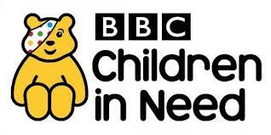
Your Kindness counts!!
The children from Holy Family will have the opportunity to become ‘Kindness Ambassadors’ when they dress up for ‘Children in Need’ on Friday the 19th November 2021. Our chosen charity is ‘The Northern Ireland Children’s Hospice.’
Northern Ireland Hospice and Northern Ireland Children’s Hospice relies on kindness and kindness helps the charity do wonderful work.
The Children in Holy Family believe in the mantra:
’Kindness begins with me’.
Thank you for your continued support.

